IMPACT Lexicon Tool

database tables in use



IMPACT Lexicon Tool – database tables in use

About this document
This document describes which tables in the MySQL database are used by the IMPACT Lexicon Tool as it is now. It should be stressed that things are quite liable to change in the near future and also that the Lexicon Structure deliverable (aka the Lexicon Cookbook) describes the database as well, and in fact to a greater extend. This document is only made as a quick reference and should in the end be merged with the aforementioned Lexicon Structure document and cease to exist on its own.

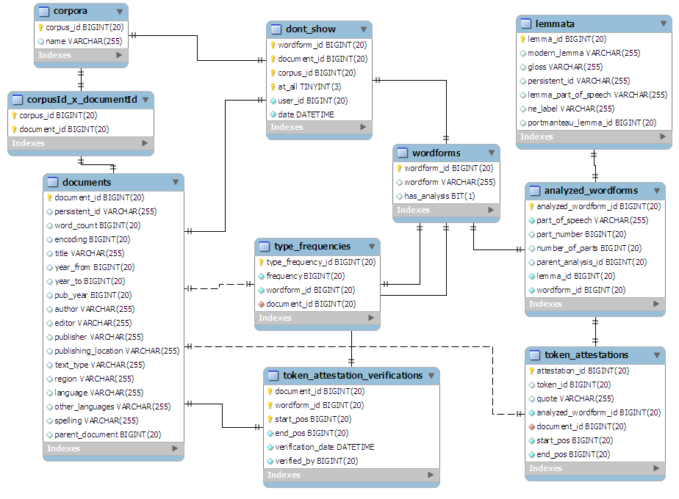

About the database structure
The idea underlying the database structure is that corpora contain documents and documents contain word forms. A word form can be lemmatized (i.e. associated with a certain lemma) via the analyzed word form table.
There are a lot of tables in the database that are not used at the moment. They might be used in future releases. This document only states the documents that are being used.

Tables and their use
In what follows the tables are discussed in more or less top down manner.

Table users
user_id | Internal identifier of the user
name | Name of the user

As is mentioned in the manual, this table is the only one that needs to have at least one row before the interface can be used.

Table corpora
corpus_id | Internal identifier of the corpus
name | Name as typed in by the user

Table documents
The documents table has a lot of columns which are not right now. Here, only the relevant ones are stated.

document_id | Internal identifier of the document
title | Name of the document.  At the moment this is in fact the full path name which is also used by the application.  (So, as an aside for more advantaged users, if you want to copy a lexicon database and use it on another system, you can quite easily do so, but you should also copy the files lsited in this able and adjust the paths in this column to match their new locations).

Table corpusId_x_documentId
This table tells which documents belong to which corpus. Note that a document can belong to several corpora.

corpus_id | Identifier of a corpus.
document_id | Identifier of a document belonging to that corpus.

Table type_frequencies
type_frequency_id | Internal identifier.
frequency | frequency of the word form in this document.
wordform_id | Identifier of word form.
document_id | Identifier of the document it appears in.

This table is added to when a new document is uploaded.

Table lemmata
lemma_id | Internal identifier.
modern_lemma | Head word of the lemma.
gloss | Optional field that can be used for distinguishing between similar lemmata.
persistent_id | Not used at the moment
lemma_part_of_speech | Part of speech of this lemma.
ne_label | Not used at the moment
portmanteau_lemma_id | Not used at the moment

Table analyzed_wordforms
analyzed_wordform_id | Internal identifier.
part_of_speech | Not used at this level. Rather, the lemma_part_of_speech is used
part_number | Not used right now.  Will be used in case of multiword expressions.
number_of_parts | Not used right now.  Will be used in case of clitics.
parent_analysis_id | Not used right now.  Will be used in case of multiword expressions.
lemma_id | Identifier of the lemma.
wordform_id | Identifier of the word form.

Table wordforms
wordform_id | Internal identifier
wordform | String describing the word form.  This is case sensitive (i.e. monkey and MonKey will each have their own record).
has_analysis | Not used at the moment.

Table token_attestations
In the Lexicon Structure document this table is being referred to as token_level_attestations.
It should be noted that token and word form mean the same in this context.

attestation_id | Internal identifier.
token_id | Not used right now.
quote | Not used right now.
analyzed_wordform_id | Identifier of the associated analyzed word form.
document_id | Document this word form appears in.
start_pos | Offset of the start of the word form in the document.
end_pos | Offset of the end of the word form in the document.

Table token_attestation_verifications
This table quite closely resembles the token_attestations table described above. The reason the two are separate is because a token in a sentence can have no analysis associated to it (i.e. it is not attested) and still be verified (this would mean as much as: "This word form has no analyses in this context and I verify this being the case").

document_id | Identifier of the document the verified word form occurs in.
wordform_id | Identifier of the word form that is verified.
start_pos | Start position of the word form in the document.
end_pos | End position of the word form in the document.
verification_date | The moment it was verified (set by the tool at the moment of clicking)
verified_by | The user that verified.

Tables text_attestations
This table (and also the table text_attestation_verifications) is not in use at the moment, but might be in the future. To avoid confusion we just mention here that this table is referred to in the Lexicon Structure document as type_level_attestations.

Table dont_show
One can hide word forms for a document, for a corpus and forever. This table keeps track of the hidden word forms.

wordform_id | Identifier of the word form being hidden.
document_id | Identifier of the document this word form is hidden for.
corpus_id | Identifier of the corpus this word form is hidden for.
at_all | If the word is not be shown at all, this column will have a non-zero value.
user_id | The user that hid the word.
date | The moment it was hidden.

